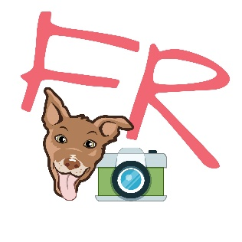
PLEASE READ THIS CAREFULLY.
It affects any rights you may have if you or anybody you bring along are injured or otherwise suffer damages while participating with Fenway’s Runway (Caroline Rodgers). It also states your responsibility regarding fees and expectations associated with staying with us.
I, _____________________________________(participant) herby agree to the following covenants described below regarding Fenway’s Runway services.
I further release, waive, discharge and covenant not to sue Fenway’s Runway (Caroline Rodgers or any other agent or care taker) for any liability, claim, and/or cause of action arising out of or related to any loss, damage or injury, including death, that occurs as a result of my participation in the below described activities.
- Participation with us is voluntary. We reserve the right to excuse any dog at any time for negative behavior. In this instance, you are responsible for retrieving your dog (same day) and making other arrangements.
- Participating pets are to be current on their vaccinations. These include but are not limited to a current DHPP (distemper) vaccine (3year), a Bordatella (1year), and a Rabies vaccine (3year). By signing this agreement, you certify that your pet is current on his/her vaccinations. We also require that participating dogs have a negative fecal exam every six months and that all dogs over eleven months of age be spayed or neutered.
- Fenway’s Runway (Caroline Rodgers) herby has permission to use any photos taken of you and/or your dog during their stay for advertising purposes. These images are also for sale. Photos used online, with or without permission, will include photo credit to Fenway’s Runway (Caroline Rodgers).
- When at the dog park, your pet will be supervised at all times. However, any time groups of dogs play together, there is a chance of injury. By signing below, I am giving permission for my dog to play with other dogs and play on dog park equipment.
- If I do not cancel within a 48 hour window, or am a no-show for any scheduled services, I will be held responsible to pay in full same day.
- If your pet does become ill or injured, and we are unable to reach you, please indicate your wishes below:
_________Please perform whatever services the doctor deems necessary for the best care of my pet until someone is reached.
_________I authorize up to $__________
_________Do not administer any medical services until specific authorization is given by me or my emergency contact

By signing this disclaimer, agreement and waiver, I state that I have read and understand the conditions set forth in this disclaimer, agreement and waiver, and that I agree to all conditions set forth herein, and that I sign this voluntarily.
Name__________________________________Signature_______________________________
Phone #____________________________ Pet Name___________________________________ Date_________________________Address____________________________________________
I do acknowledge and can confidently say that my pet is;
- Spay/Neutered (over 11 months)
- Potty trained
- Non-aggressive
- Up to date on vaccinations
- On flea preventative
- Crate trained (dog only)
- Any damage caused by your pet will be reimbursed by pet owner

___________________________________ ________________________________________
(PRINT NAME) (SIGN)

Our vet is Dr. _______________ Office Name ____________________________________
Vet Phone # _____________________________________
Your email address _________________________________Your Phone # ______________________
If you cannot be reached, in case of emergency please call _____________ @______________________

All dogs must be bathed and/or groomed prior to their visit with us!
All fees are due and payable in advance of service (prior to drop off)
We accept cash or Venmo (@FenwaysRunway)

THANK YOU for supporting small & woman owned!
Please be sure to LIKE, FOLLOW, CHECK-IN & REVIEW!
www.FENWAYSRUNWAY.com
@FenwaysRunway #FenwaysRunway

